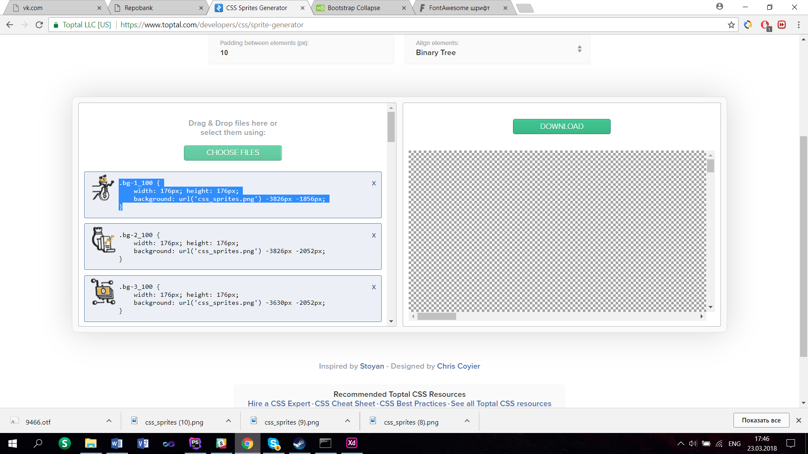

.bg-1_100 {

width: 176px; height: 176px;

background: url('css_sprites.png') -3826px -1856px;

}

.bg-2_100 {

width: 176px; height: 176px;

background: url('css_sprites.png') -3826px -2052px;

}

.bg-3_100 {

width: 176px; height: 176px;

background: url('css_sprites.png') -3630px -2052px;

}

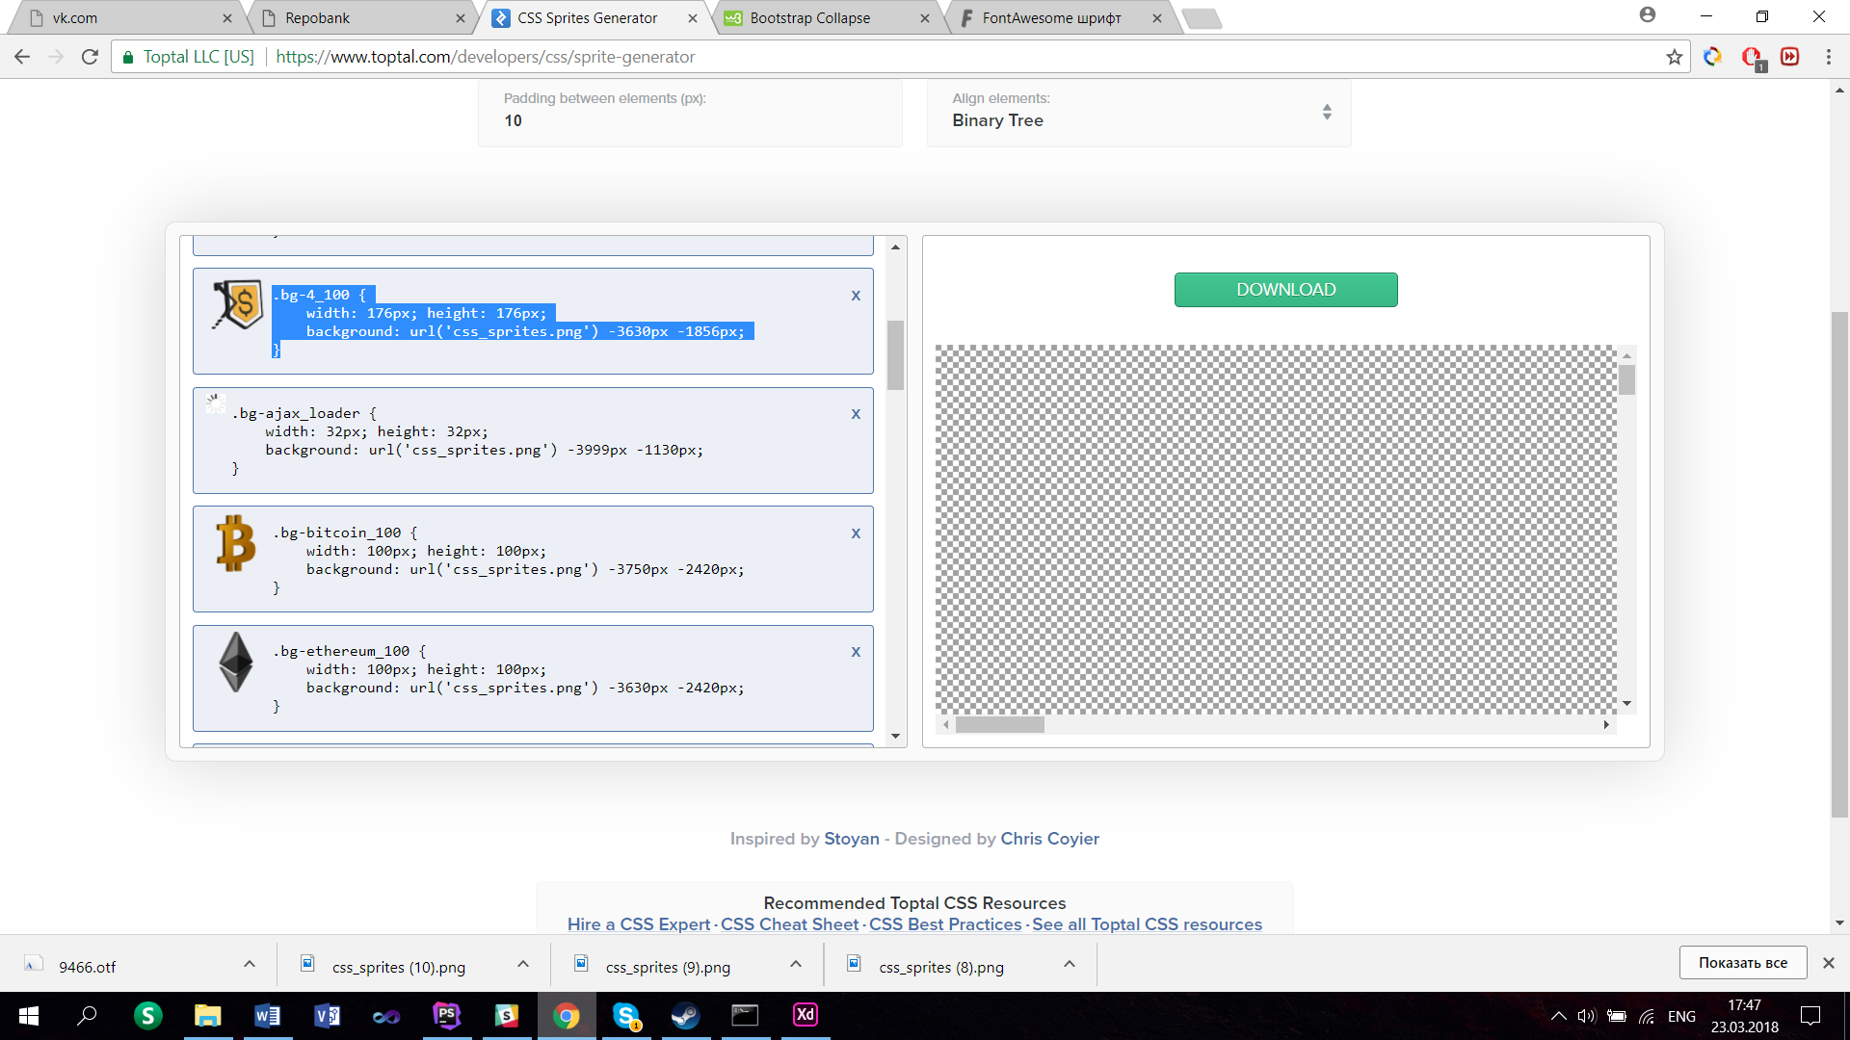

.bg-4_100 {

width: 176px; height: 176px;

background: url('css_sprites.png') -3630px -1856px;}

.bg-ajax_loader {

width: 32px; height: 32px;

background: url('css_sprites.png') -3999px -1130px;

}

.bg-bitcoin_100 {

width: 100px; height: 100px;

background: url('css_sprites.png') -3750px -2420px;

}

.bg-ethereum_100 {

width: 100px; height: 100px;

background: url('css_sprites.png') -3630px -2420px;

}

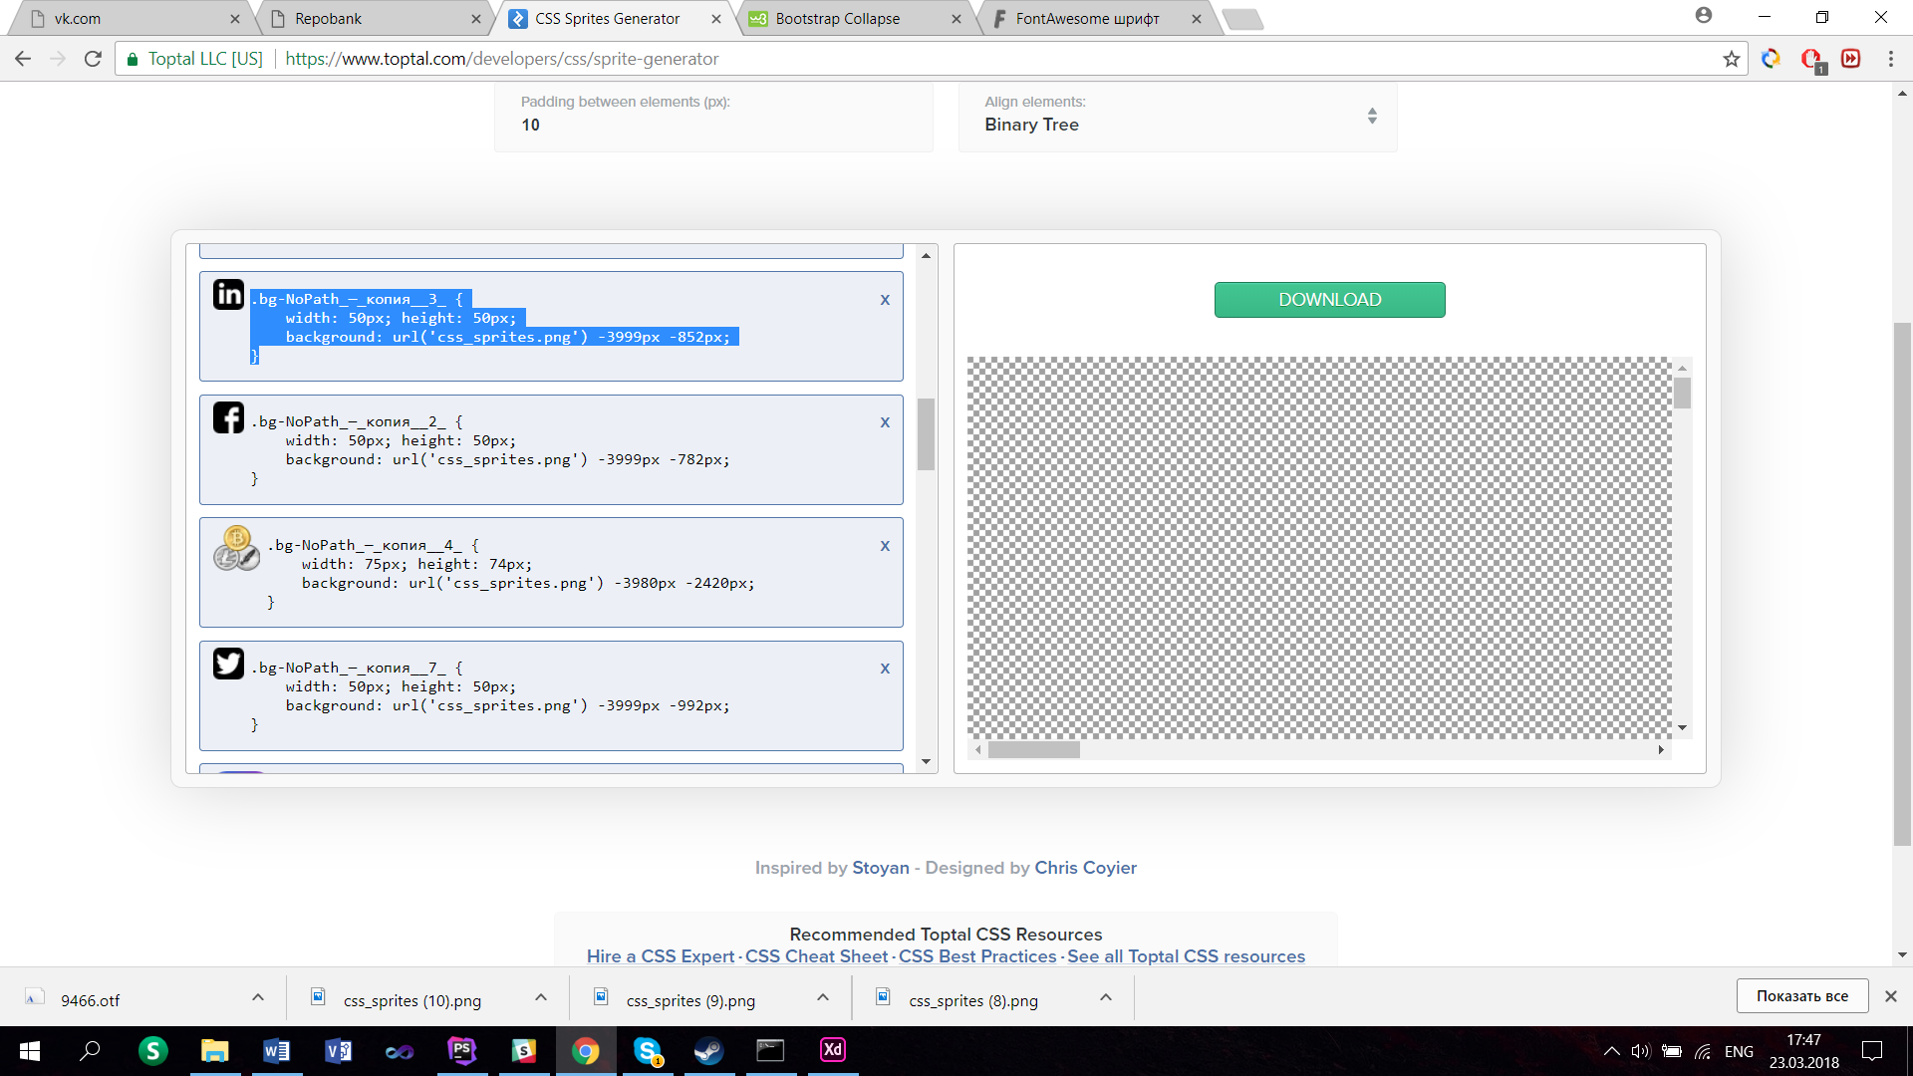

.bg-NoPath_—_копия__3_ {

width: 50px; height: 50px;

background: url('css_sprites.png') -3999px -852px;

}

.bg-NoPath_—_копия__2_ {

width: 50px; height: 50px;

background: url('css_sprites.png') -3999px -782px;

}

.bg-NoPath_—_копия__4_ {

width: 75px; height: 74px;

background: url('css_sprites.png') -3980px -2420px;

}

.bg-NoPath_—_копия__7_ {

width: 50px; height: 50px;

background: url('css_sprites.png') -3999px -992px;

}

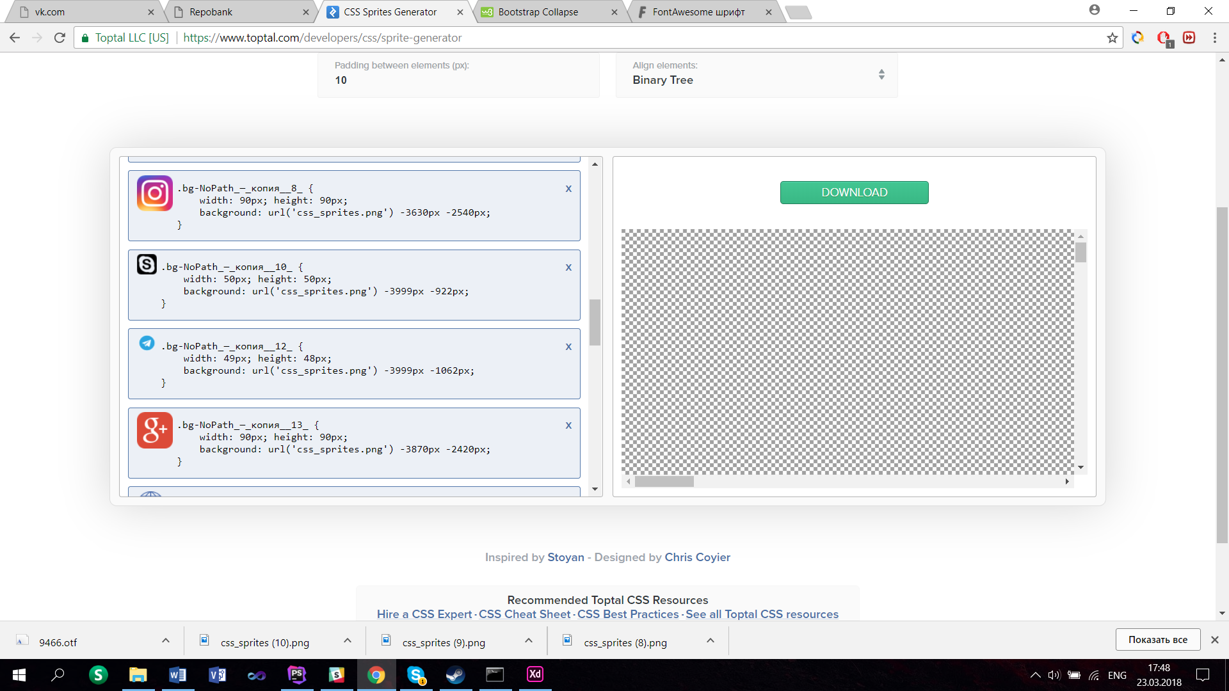

.bg-NoPath_—_копия__8_ {

width: 90px; height: 90px;

background: url('css_sprites.png') -3630px -2540px;

}

.bg-NoPath_—_копия__10_ {

width: 50px; height: 50px;

background: url('css_sprites.png') -3999px -922px;

}

.bg-NoPath_—_копия__12_ {

width: 49px; height: 48px;

background: url('css_sprites.png') -3999px -1062px;

}

.bg-NoPath_—_копия__13_ {

width: 90px; height: 90px;

background: url('css_sprites.png') -3870px -2420px;

}

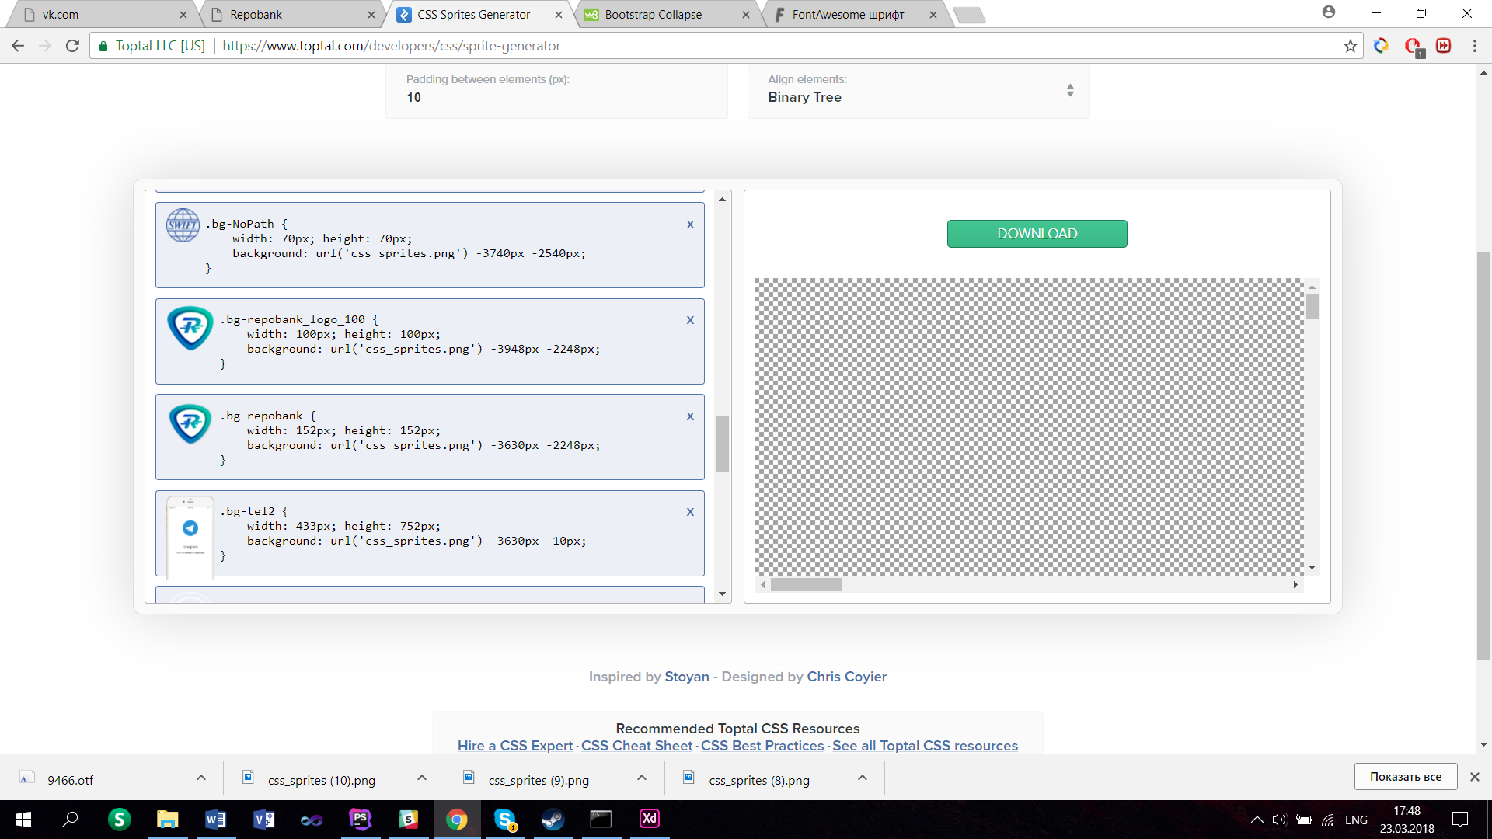

.bg-NoPath {

width: 70px; height: 70px;

background: url('css_sprites.png') -3740px -2540px;

}

.bg-repobank_logo_100 {

width: 100px; height: 100px;

background: url('css_sprites.png') -3948px -2248px;

}

.bg-repobank_logo_100 {

width: 100px; height: 100px;

background: url('css_sprites.png') -3948px -2248px;

}

.bg-tel2 {

width: 433px; height: 752px;

background: url('css_sprites.png') -3630px -10px;

}

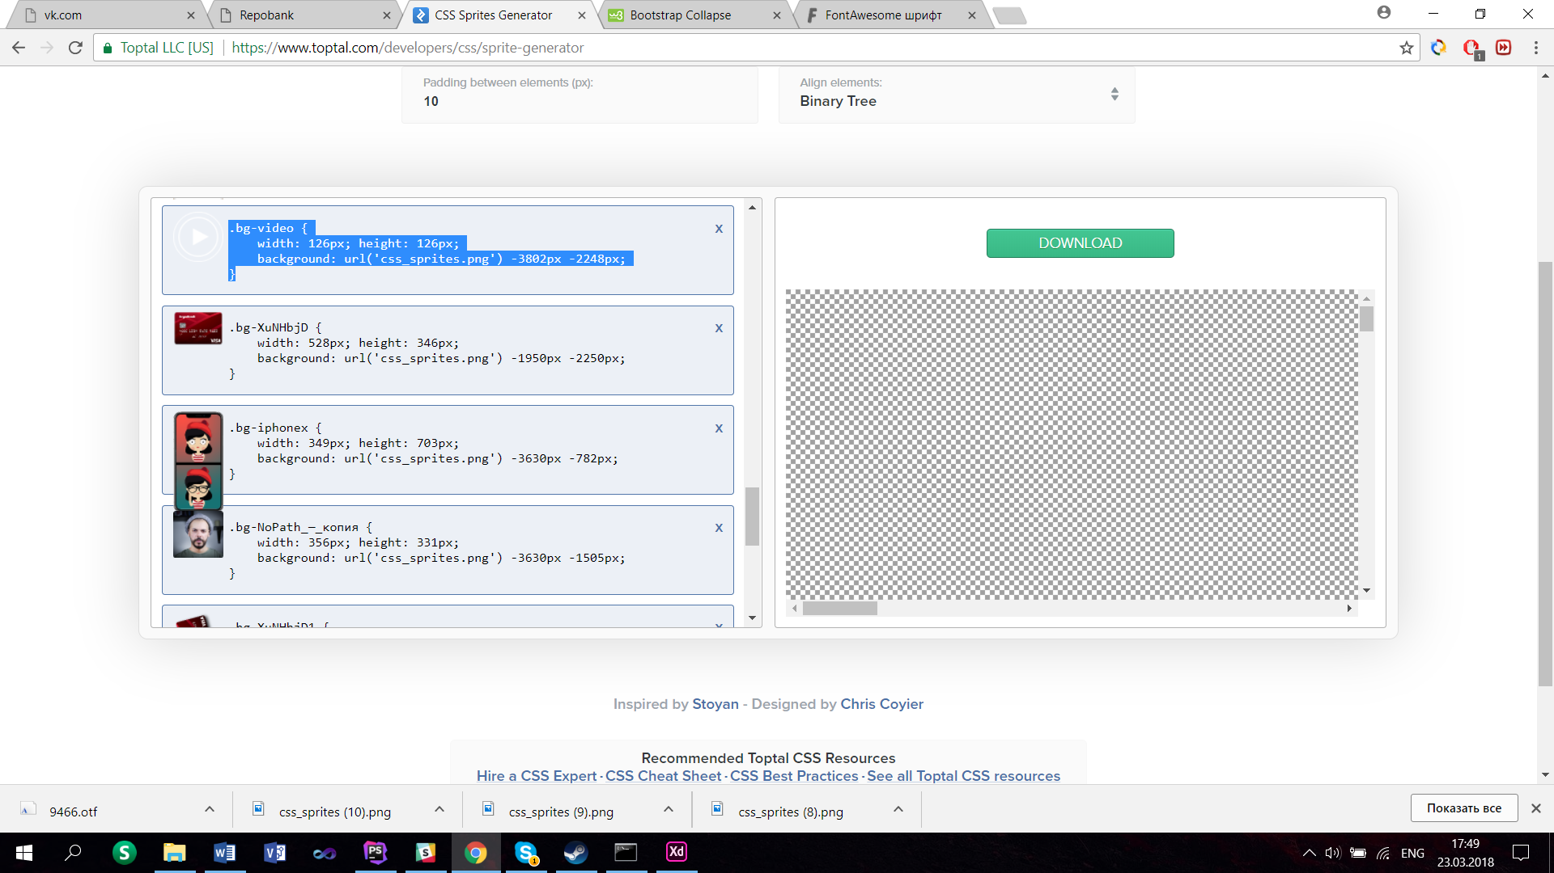

.bg-video {

width: 126px; height: 126px;

background: url('css_sprites.png') -3802px -2248px;

}

.bg-XuNHbjD {

width: 528px; height: 346px;

background: url('css_sprites.png') -1950px -2250px;

}

.bg-iphonex {

width: 349px; height: 703px;

background: url('css_sprites.png') -3630px -782px;

}

.bg-NoPath_—_копия {

width: 356px; height: 331px;

background: url('css_sprites.png') -3630px -1505px;

}

.bg-XuNHbjD1 {

width: 530px; height: 659px;

background: url('css_sprites.png') -2970px -1530px;

}

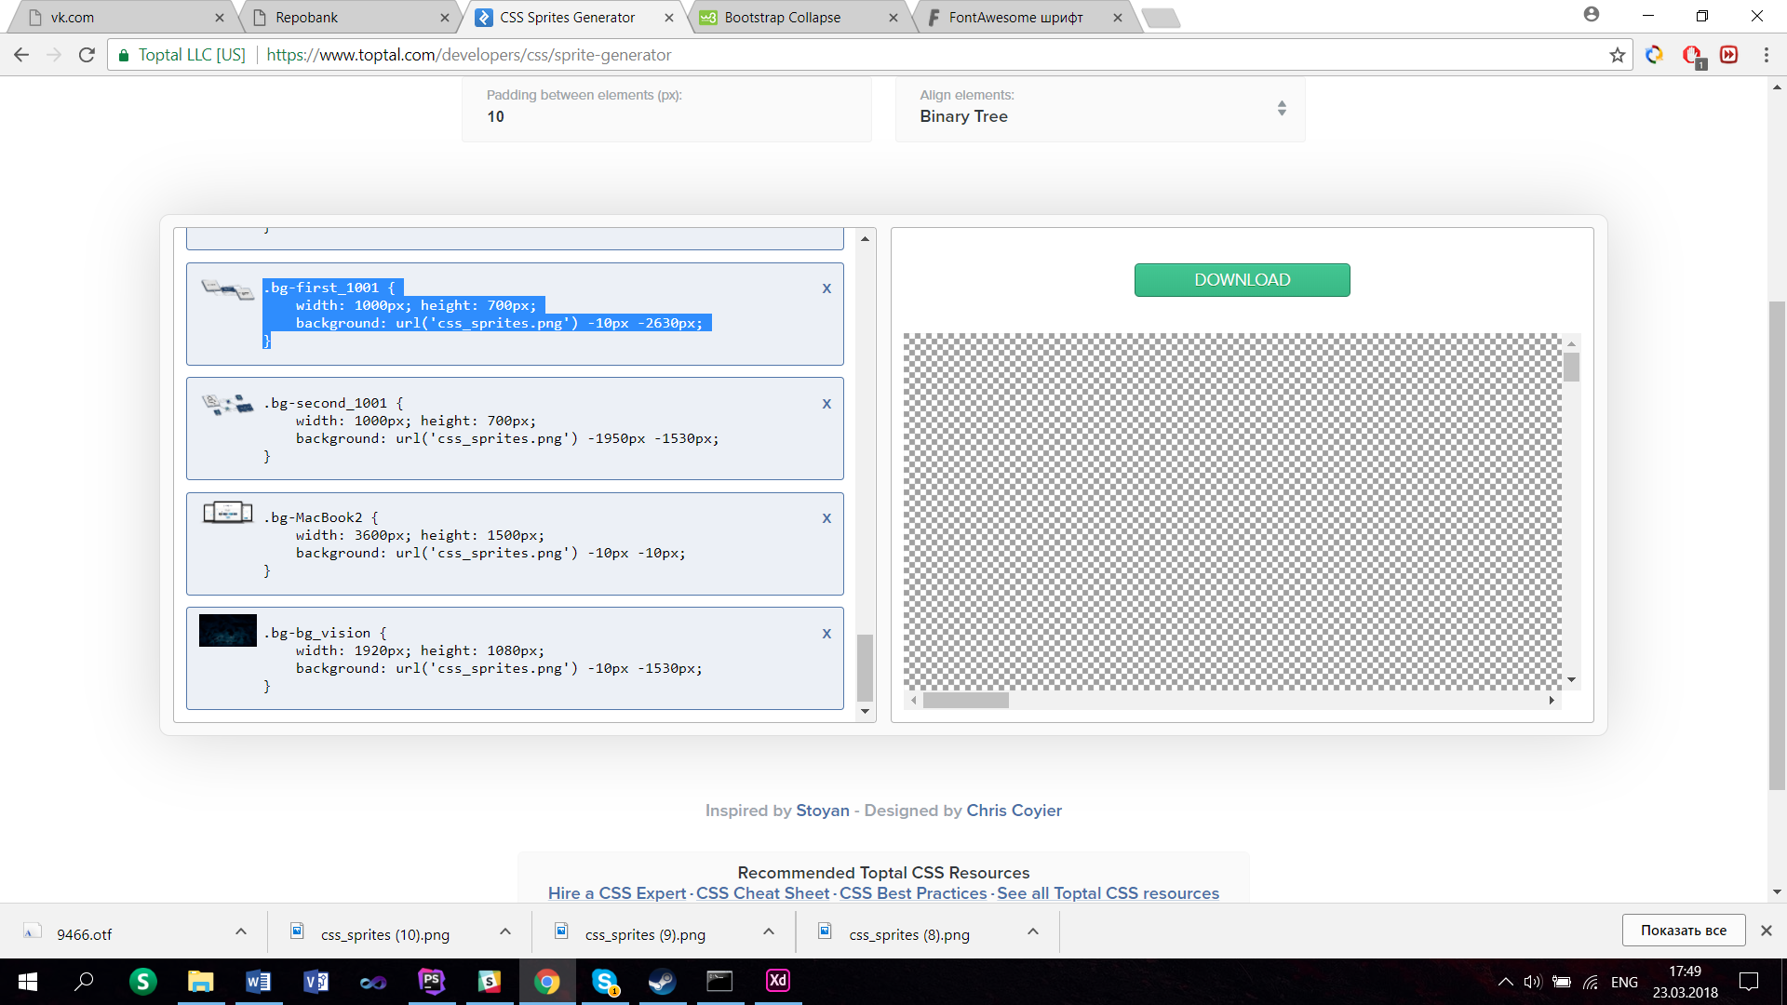

.bg-first_1001 {

width: 1000px; height: 700px;

background: url('css_sprites.png') -10px -2630px;

}

.bg-second_1001 {

width: 1000px; height: 700px;

background: url('css_sprites.png') -1950px -1530px;

}

.bg-MacBook2 {

width: 3600px; height: 1500px;

background: url('css_sprites.png') -10px -10px;

}

.bg-bg_vision {

width: 1920px; height: 1080px;

background: url('css_sprites.png') -10px -1530px;

}